Activity | Data Type
Number of beatings from Wife | discrete
Results of rolling a dice | discrete
Weight of a person | continuous
Weight of Gold | continuous
Distance between two places | continuous
Length of a leaf | continuous
Dog's weight | continuous
Blue Color | discrete
Number of kids | discrete
Number of tickets in Indian railways | discrete
Number of times married | discrete
Gender (Male or Female) | discrete
Q1) Identify the Data type for the Following:

Q2) Identify the Data types, which were among the following
Nominal, Ordinal, Interval, Ratio.
Data | Data Type
Gender | nominal
High School Class Ranking | ordinal
Celsius Temperature | interval
Weight | ratio
Hair Color | nominal
Socioeconomic Status | ordinal
Fahrenheit Temperature | interval
Height | ratio
Type of living accommodation | ordinal
Level of Agreement | ordinal
IQ(Intelligence Scale) | interval
Sales Figures | ratio
Blood Group | nominal
Time Of Day | ordinal
Time on a Clock with Hands | ordinal
Number of Children | ordinal
Religious Preference | ordinal
Barometer Pressure | interval
SAT Scores | interval
Years of Education | ordinal

Q3) Three Coins are tossed, find the probability that two heads and one tail are obtained?
HHH,TTT,HTH,THT,THH,HTT,HHT,TTH
H = 3
T = 3
Q4) Two Dice are rolled, find the probability that sum is
- Equal to 1 - 0
- Less than or equal to 4 – 2,2 3,1 1,3
- Sum is divisible by 2 and 3 = 36 outcomes out of which 24 outcomes are divisible by 2 and 3 hence 24/36 = 2/3 = 0.66//
Q5) A bag contains 2 red, 3 green and 2 blue balls. Two balls are drawn at random. What is the probability that none of the balls drawn is blue?
No of balls 7 – 7x6/2x1 = 21
After two balls drawn it is 5 – 5x4/2x1 = 10
P(E)= n(E)/n(S) = 10/21
Q6) Calculate the Expected number of candies for a randomly selected child
Below are the probabilities of count of candies for children (ignoring the nature of the child-Generalized view)
CHILD | Candies count | Probability
A | 1 | 0.015
B | 4 | 0.20
C | 3 | 0.65
D | 5 | 0.005
E | 6 | 0.01
F | 2 | 0.120
Child A – probability of having 1 candy = 0.015.
Child B – probability of having 4 candies = 0.20

= 0.015 x 1 + 0.20 x 4 + 0.65 x 3 + 0.005 x 5 + 0.01 x 6 + 0.120 x 2
=0.015 + 0.8 + 1.95 + 0.025 + 0.06 + 0.24
= 3.09//

Q7) Calculate Mean, Median, Mode, Variance, Standard Deviation, Range & comment about the values / draw inferences, for the given dataset
- For Points,Score,Weigh>
Find Mean, Median, Mode, Variance, Standard Deviation, and Range and also Comment about the values/ Draw some inferences.
Use Q7.csv file
MEAN

Points 3.596563
Score 3.217250
Weigh 17.848750
dtype: float64

MEDIAN

Points 3.695
Score 3.325
Weigh 17.710
dtype: float64

MODE
 | Unnamed: 0 | Points | Score | Weigh
0 | AMC Javelin | 3.07 | 3.44 | 17.02
1 | Cadillac Fleetwood | 3.92 | NaN | 18.90
2 | Camaro Z28 | NaN | NaN | NaN
3 | Chrysler Imperial | NaN | NaN | NaN
4 | Datsun 710 | NaN | NaN | NaN
5 | Dodge Challenger | NaN | NaN | NaN
6 | Duster 360 | NaN | NaN | NaN
7 | Ferrari Dino | NaN | NaN | NaN
8 | Fiat 128 | NaN | NaN | NaN
9 | Fiat X1-9 | NaN | NaN | NaN
10 | Ford Pantera L | NaN | NaN | NaN
11 | Honda Civic | NaN | NaN | NaN
12 | Hornet 4 Drive | NaN | NaN | NaN
13 | Hornet Sportabout | NaN | NaN | NaN
14 | Lincoln Continental | NaN | NaN | NaN
15 | Lotus Europa | NaN | NaN | NaN
16 | Maserati Bora | NaN | NaN | NaN
17 | Mazda RX4 | NaN | NaN | NaN
18 | Mazda RX4 Wag | NaN | NaN | NaN
19 | Merc 230 | NaN | NaN | NaN
20 | Merc 240D | NaN | NaN | NaN
21 | Merc 280 | NaN | NaN | NaN
22 | Merc 280C | NaN | NaN | NaN
23 | Merc 450SE | NaN | NaN | NaN
24 | Merc 450SL | NaN | NaN | NaN
25 | Merc 450SLC | NaN | NaN | NaN
26 | Pontiac Firebird | NaN | NaN | NaN
27 | Porsche 914-2 | NaN | NaN | NaN
28 | Toyota Corolla | NaN | NaN | NaN
29 | Toyota Corona | NaN | NaN | NaN
30 | Valiant | NaN | NaN | NaN
31 | Volvo 142E | NaN | NaN | NaN

VARIANCE

Points 0.285881
Score 0.957379
Weigh 3.193166
dtype: float64

STANDARD DEVIATION
Points 0.534679
Score 0.978457
Weigh 1.786943
dtype: float64

RANGE – 21.39//

Draw inference – uneven distribution with outliers found.

Q8) Calculate Expected Value for the problem below
- The weights (X) of patients at a clinic (in pounds), are
108, 110, 123, 134, 135, 145, 167, 187, 199
Assume one of the patients is chosen at random. What is the Expected Value of the Weight of that patient?
Expected value:- 153.3

Q9) Calculate Skewness, Kurtosis & draw inferences on the following data
Cars speed and distance
Use Q9_a.csv
Skewness

Index 0.000000
speed -0.117510
dist 0.806895
dtype: float64

Kurtosis

Index -1.200000
speed -0.508994
dist 0.405053
dtype: float64

Inferences
Speed – left skewed, kurtosis is negative
Distance – right skewed, kurtosis is positive

SP and Weight(WT)
Use Q9_b.csv
Skewness

Unnamed: 0 0.000000
SP 1.611450
WT -0.614753
dtype: float64

Kurtosis

Unnamed: 0 -1.200000
SP 2.977329
WT 0.950291
dtype: float64

Inferences

Sp - right skewed, positive kurtosis
Weight – non symmetric distribution with outliers no right or left skewed mostly peak at centre.

Q10) Draw inferences about the following boxplot & histogram
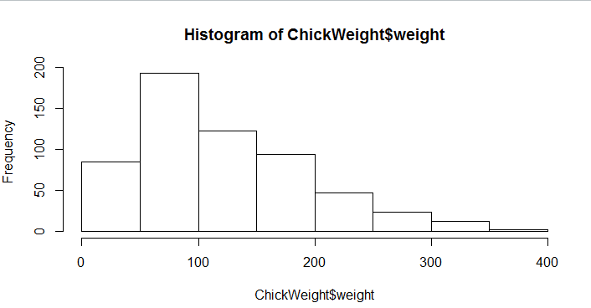
Right skewed
Mean greater than median
More weight and peak between 50 - 100

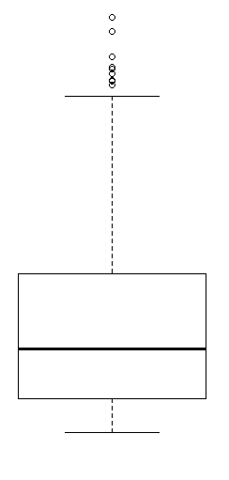
Right skewed boxplot
Outliers found in upperside.

Q11) Suppose we want to estimate the average weight of an adult male in Mexico. We draw a random sample of 2,000 men from a population of 3,000,000 men and weigh them. We find that the average person in our sample weighs 200 pounds, and the standard deviation of the sample is 30 pounds. Calculate 94%,98%,96% confidence interval?
Cf 94% - 1.04
Cf 96% - 1.17
Cf 98% - 1.37
Q12) Below are the scores obtained by a student in tests
34,36,36,38,38,39,39,40,40,41,41,41,41,42,42,45,49,56
- Find mean, median, variance, standard deviation.
- What can we say about the student marks?
Mean – 41
Median – 40
Variance – 24.1
Standard deviation – 4.9
Most of the test scores/ marks are between 40 and 41.

Q13) What is the nature of skewness when mean, median of data are equal?
Perfectly skewed
Q14) What is the nature of skewness when mean > median ?
Positive or Right skewed
Q15) What is the nature of skewness when median > mean?
Left skewed
Q16) What does positive kurtosis value indicates for a data ?
Distribution is bellshaped/sharp/very high in particular area.
Q17) What does negative kurtosis value indicates for a data?
Distribution is denoting flat peak not bell shaped curve which is indicating that un even distribution spread out at every interval.
Q18) Answer the below questions using the below boxplot visualization.
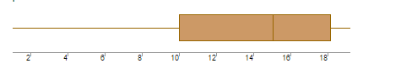
What can we say about the distribution of the data?
Not normally distributed / non symmetric distribution of data.
What is nature of skewness of the data?
Left skewed.
What will be the IQR of the data (approximately)?
IQR = Q3 – Q1
IQR = 18-10
IQR = 8.
Q19) Comment on the below Boxplot visualizations?
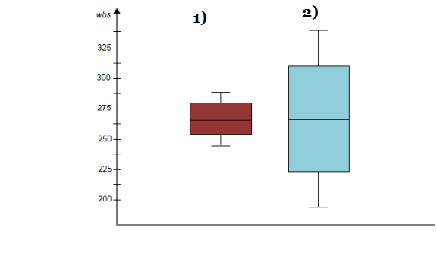
Draw an Inference from the distribution of data for Boxplot 1 with respect Boxplot 2.
High level of equal distribution found in boxplot 1.
But both boxplot medians are in same level.
Boxplot 2 represent spread out distribution.

Q 20) Calculate probability from the given dataset for the below cases

Data _set: Cars.csv
Calculate the probability of MPG of Cars for the below cases.
MPG <- Cars$MPG
  - P(MPG>38) = 0.67//
  - P(MPG<40) = 0.74//
  - P (20<MPG) = 0.059//
  - P (50>MPG) = 0.96//

Q 21) Check whether the data follows normal distribution
- Check whether the MPG of Cars follows Normal Distribution
Dataset: Cars.csv
MPG of cars not following normal distribution.
Histogram of MPG as follows,
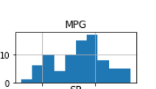

- Check Whether the Adipose Tissue (AT) and Waist Circumference(Waist) from wc-at data set follows Normal Distribution
Dataset: wc-at.csv

Adipose Tissue (AT) and Waist Circumference(Waist) not following normal distribution and their histogram as follows,

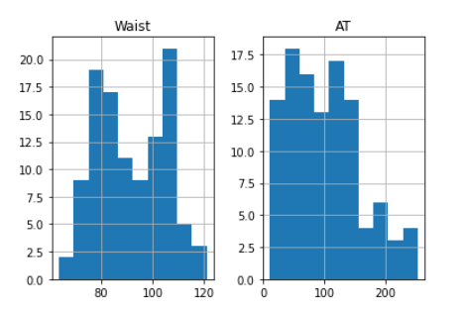

Q 22) Calculate the Z scores of 90% confidence interval,94% confidence interval, 60% confidence interval

Z score

90% - 1.282
94% - 1.555
60% - 0.253
Q 23) Calculate the t scores of 95% confidence interval, 96% confidence interval, 99% confidence interval for sample size of 25
T scores
95% - 2.0639
96% - 2.4922
99% - 2.797

Q 24) A Government company claims that an average light bulb lasts 270 days. A researcher randomly selects 18 bulbs for testing. The sampled bulbs last an average of 260 days, with a standard deviation of 90 days. If the CEO's claim were true, what is the probability that 18 randomly selected bulbs would have an average life of no more than 260 days
Hint:
rcode → pt(tscore,df)
df → degrees of freedom
x = mean of the sample of bulbs = 260
mean = population mean = 270
s = standard deviation of the sample = 90
n = number of items in the sample = 18
t = 260 – 270/90/√18
t = -10/90/3√2
t = -10 /30/√2
t = -1 x √2/3
t = - 0.471
Probability t < - 0.471 with 17 degrees of freedom.

